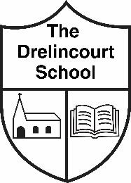
(Appendix 3)
Positive Behaviour Policy
(Parents information summary leaflet)

Our aim is to promote positive behaviour at all times through the use of simple school rules, class rules and reward systems.

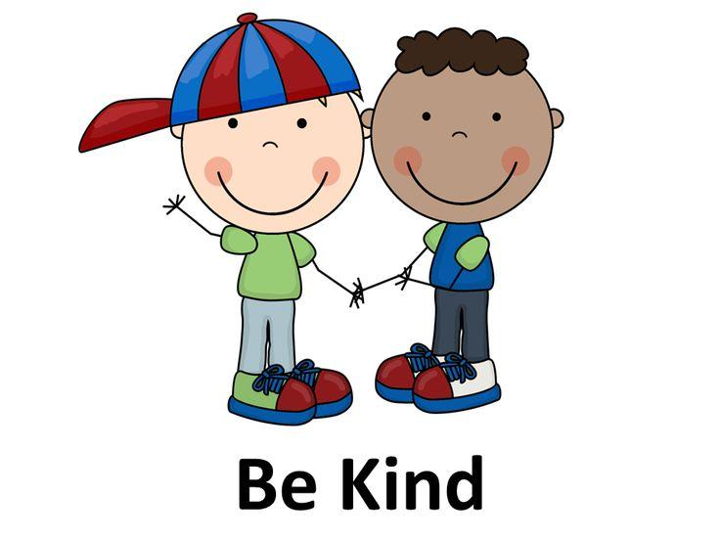
School Rules
1. We are kind
2. We always do our best
3. We look after our school

Class Rules
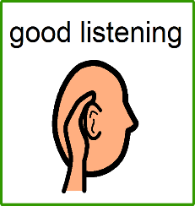  1. | 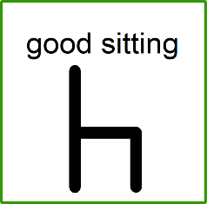  2. | 3.
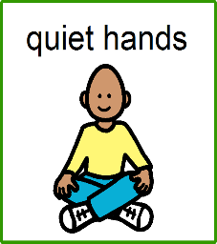  4. | 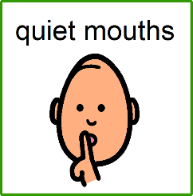  5. | Please reinforce these rules with your child at home

Rewards
Your child will be praised and rewarded for good behaviour through eg:
- Stickers
- Teacher’s certificates
- Tokens and golden cards – Leading onto ‘Golden Time’ and small prizes

*A copy of our ‘Positive Behaviour Policy’ can be found on our school website.

