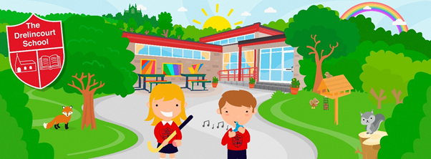

The Drelincourt School
Child Protection Policy
Summary Guide for Parents
The School’s Safeguarding Team:
Designated Teacher: Mrs Eileen Trew (Principal)
Deputy Designated Teacher: Mrs Sharon Walker
Designated Governor: Mrs Florence Lawson
Chair of Governors: The Most Revd F. J. McDowell

Email:info@thedrelincourt.armagh.ni.sch.uk
Website:www.drelincourt.org.uk
Phone:02837523714

Introduction
We have a responsibility for the safeguarding and child protection of the children in our care and we will carry out this duty by providing a caring, supportive and safe environment, where each child is valued for his or her unique talents and abilities, and in which all our children can learn and develop to their full potential. All staff, teaching and non-teaching should be alert to the signs of possible abuse and should know the procedures to be followed. This Policy sets out guidance on the action, which is required where abuse or harm to a child is suspected and outlines referral procedures within our school

Guiding Principles
- Every child has the right to be heard, safe, listened to and taken seriously.
- The welfare of the child is paramount at all times
- Parents are supported to exercise parental responsibility and families helped stay together;
- Partnership;
- Prevention;

Responsibility to Report
Any member of staff who knows or suspects that a pupil is being harmed or at risk of being harmed has a duty to report this concern to the Designated Teachers.

Categories of Abuse

- SEXUAL ABUSE occurs when others use and exploit children sexually for their own gratification or gain or the gratification of others.

- EMOTIONAL ABUSE is the persistent emotional maltreatment of a child. It is also sometimes called psychological abuse and it can have severe and persistent adverse effects on a child’s emotional development.

- PHYSICAL ABUSE is deliberately physically hurting a child.

- NEGLECT is the failure to provide for a child’s basic needs, whether it be adequate food, clothing, hygiene, supervision or shelter that is likely to result in the serious impairment of a child’s health or development.

- EXPLOITATION is the intentional ill-treatment, manipulation or abuse of power and control over a child or young person; to take selfish or unfair advantage of a child or young person or situation, for personal gain.

If a Parent Has a Potential Child Protection Concern Within the School

I can talk to the class teacher

I have a concern about my/a child’s safety

If I am still concerned, I can talk/write to the Chair of the Board of Governors

If I am still concerned, I can talk to the Designated/Deputy Designated Teacher for child protection or the Principal

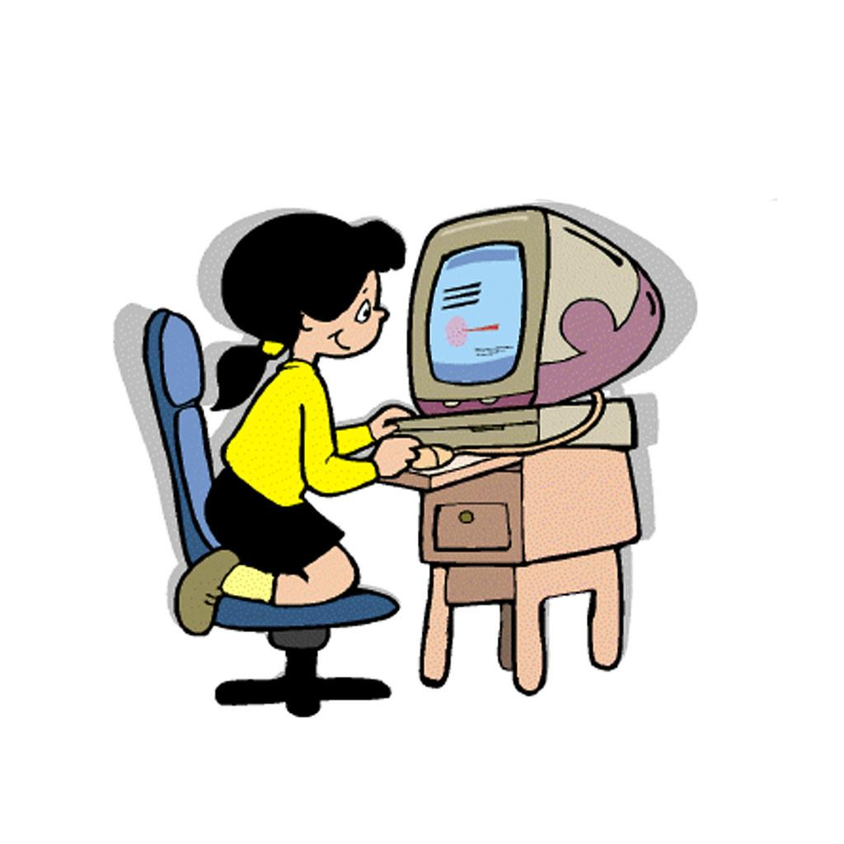

At any time I can talk to the local Children’s Services Gateway Team or the PSNI Central Referral Unit at 101
Child Protection and the Internet
It is important for children to remember that online friends may not be who they say they are. Inappropriate material is available to view by children online. Consider using filtering software and agreeing rules about what services you are happy for your children to use.

Procedure for Pupil/Teacher reporting a Safeguarding Concern

Child makes disclosure or teacher has concerns

Referral to Designated Teachers/Principal

Plan of action agreed

No referral to Social Services. Parents/Carers informed of concerns

Referral to Social Services

Follow the School’s Policy and Procedures. School will continue to support and monitor pupils as appropriate.

This leaflet is intended only as a summary of the main points of the Drelincourt School’s Child Protection Policy. The full document is available in the office or on the school website www.drelincourt.org.uk

Appendix 1
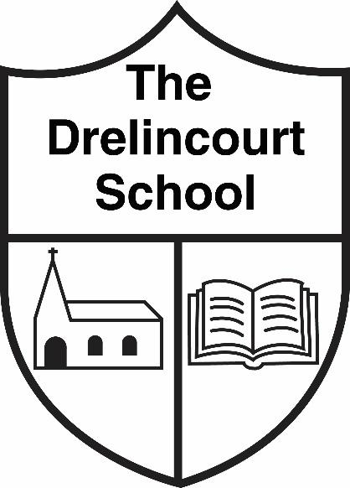

Dear parent,

You have received a ‘Summary Guide for Parents’ of our Child Protection Policy.
Please sign and return the slip below as confirmation of receipt.
Please do not hesitate to contact the school if you have any questions.

I have received the Child Protection ‘Summary Guide for Parents’ | Yes/No

Name of child:
Parent signature:
Date:

