Appendix 4
The Drelincourt School
First Aid and Administration of Medication - Parent’s Guide
PROCEDURES FOR FIRST AID AND ADMINISTRATION OF MEDICATION

At The Drelincourt School we make every effort to provide a safe environment for the children in our care. However, from time to time, accidents do occur and we aim to act quickly and provide first aid where necessary.

First Aider: Mrs S Ritchie

- Minor accident eg: a fall in the playground, the wound will be cleaned with water and sterile wipes and a plaster applied (with parental permission). Parent will be informed at hometime and a ‘Mr Bump’ note will be sent home with the child.
- Bump to the head - a cold compress will be applied and the parent will be contacted to come and take the child home for observation.
- Emergency /serious accident - staff will call 999 for an ambulance and the parent will be contacted immediately.

Medical conditions

- Medical History Form must be completed, outlining any specific medical conditions that the child may have eg: Asthma, allergies, epilepsy
- Child becomes unwell during the school day - parent will be contacted to take the child home.
- Infectious condition or sickness - child should not attend school. If a child is vomiting or has diarrhoea, the school will follow the Public Health Guidelines stating that they must be free of symptoms for at least 48 hours.
- Administration of medication throughout the day - parent must seek written permission and consent from the Principal.

COVID-19 Guidance

- If a child is unwell, he/she should not attend school
- Parent should continue to monitor their child at home for the main symptoms:
- a high temperature
- a new, continuous cough
- a loss or change to sense of smell or taste
- If a child tests positive for COVID-19, PHA guidance must be followed before returning to school.
- Staff will check child’s temperature each morning before they enter the school.

Full policy available on the school website - www.drelincourt.org.uk
Appendix 5

Dear parent,

You have received an overview of our First Aid Policy. Please sign and return the permission slip below. Please do not hesitate to contact the school if you would like to discuss this matter further.

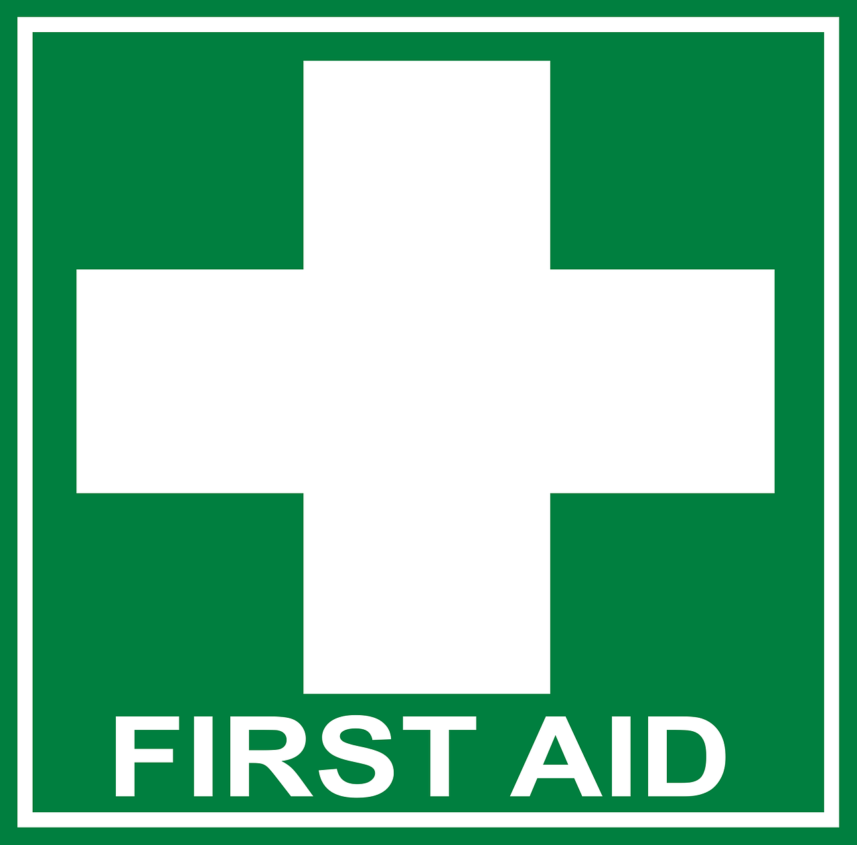
I have read the First Aid Policy and allow The Drelincourt staff to attend to my child | Yes/No
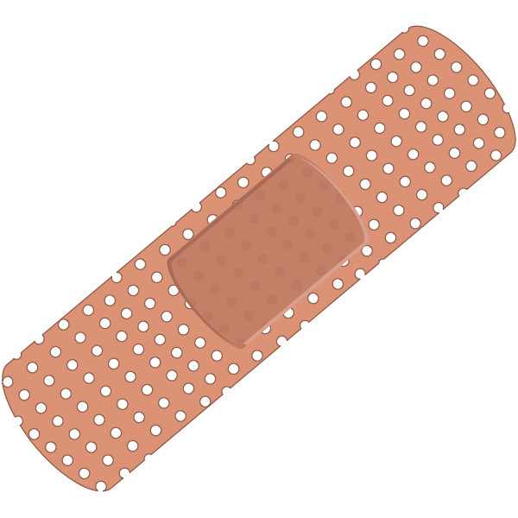  I allow The Drelincourt staff to administer plasters to my child | Yes/No
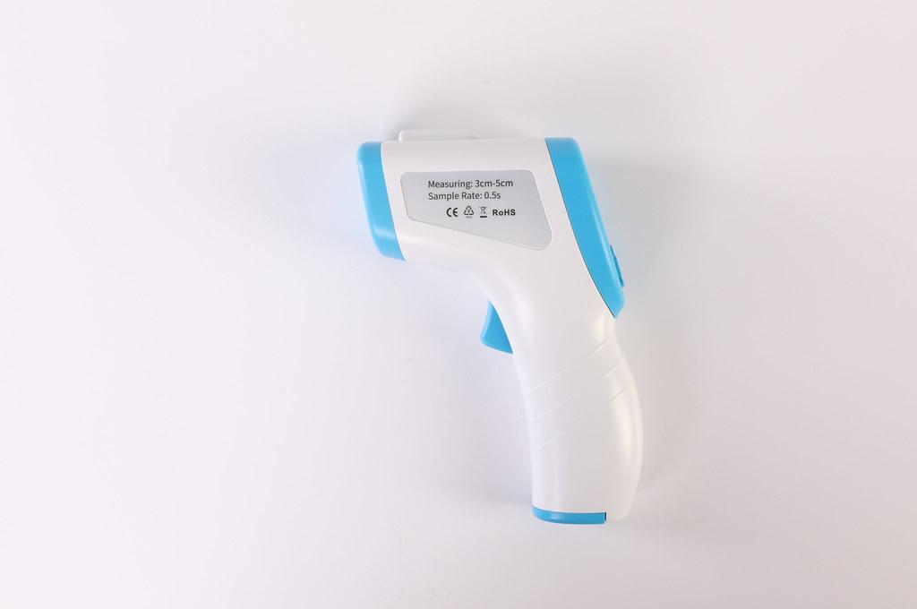  I allow my child’s temperature to be taken each morning and if he/she becomes unwell | Yes/No

Name of child:
Parent signature:
Date:

